When it gets hot
Heat-resistant BOPP films for high-speed processing
Zurich, August 19, 2026 – TPL is expanding its BOPP portfolio with several heat-resistant film types that have been specially developed for high-speed packaging. The new specialised solutions offer dimensional stability, strength, clarity and an attractive appearance. They can be used to design monomaterial packaging that meets the requirements of the PPWR.
TPL's new heat-resistant BOPP films can be processed efficiently and with consistent quality at high temperatures. They are particularly suitable for large pouches, hot fill applications, bag-in-box systems and high-speed form-fill-seal machines. The ability to treat both sides and controlled linear shrinkage ensure dimensional stability under thermal stress. Optimised hot slip and coefficient of friction (COF) ensure reliable processes on fast packaging lines, and their non-heat-sealable structure makes the films ideal for advanced lamination designs.
TPL offers heat-resistant BOPP films in transparent versions CTF-K414 (standard) and CRF-K414 (high performance). Both variants are also available in 12 µ versions to enhance material efficiency and greater sustainability without compromising functionality. In addition, the matt variant DTF-K414.
BOPP films supporting PPWR compliance
Heat-resistant BOPP films enable the design of mono-material PP packaging, facilitating mechanical recycling where appropriate recycling infrastructure exists. They help brand owners and converters develop packaging solutions aligned with the objectives and requirements of the EU Packaging and Packaging Waste Regulation (PPWR).
TPL also offers a broad portfolio of specialty BOPP films, including ultra-high barrier and low-density matt grades. Customers benefit from comprehensive application development support and technical guidance in material selection, with consideration of evolving regulatory requirements and sustainability objectives.
About TPL
TPL (Transparent Paper Ltd.), headquartered in Zurich, is a reliable partner for the flexible packaging industry and for technical applications for over 60 years and is one of Europe's leading suppliers. The owner-managed family business maintains a stock of over 14,000 tons of BOPET, BOPA, BOPP films and aluminium foil as well as shrink sleeves and offers the industry the largest selection on the market. The local sales team guarantees close exchange with customers and responds to their needs with flexibility and tailored solutions.
For more information, visit: www.tpl.ch

Text length: 2,551 characters (including spaces)

Image material:
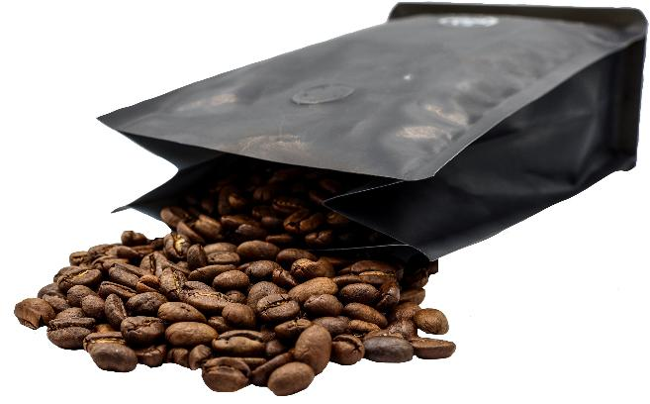
Heat-resistant BOPP films are an ideal packaging solution for many foods. (© TPL)

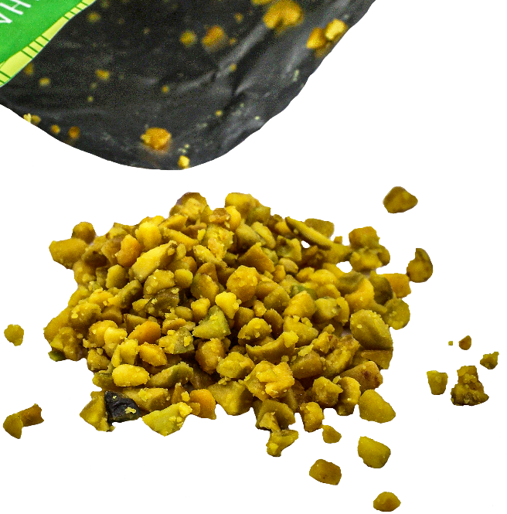
Heat-resistant BOPP films are an ideal packaging solution for many foods. (© TPL)

Company Contact:
Transparent Paper Ltd.
Thurgauerstrasse 36/38
8050 Zürich/Switzerland
Tel.: +41 44 308 92 92
eMail: marketing@tpl.ch
Web: www.tpl.ch
Press Contact:
AzetPR International Public Relations GmbH
c/o Grindelwerk
Andrea Zaszczynski
Grindelberg 17
20144 Hamburg
Tel. +49 40 41 32700
eMail: andreaz@azetpr.com

